CMSC203

Assignment #1

Document

Test runs:

In Java

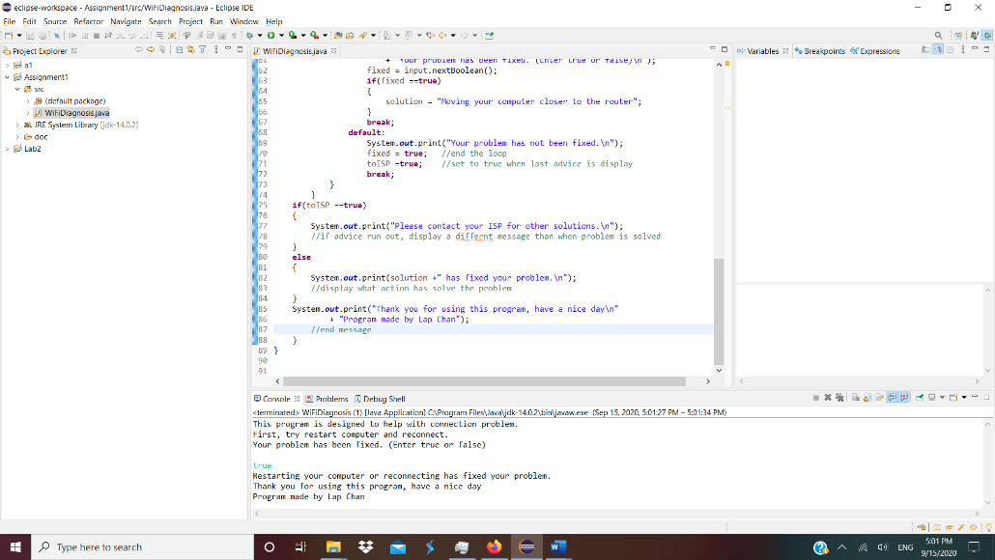

In cmd

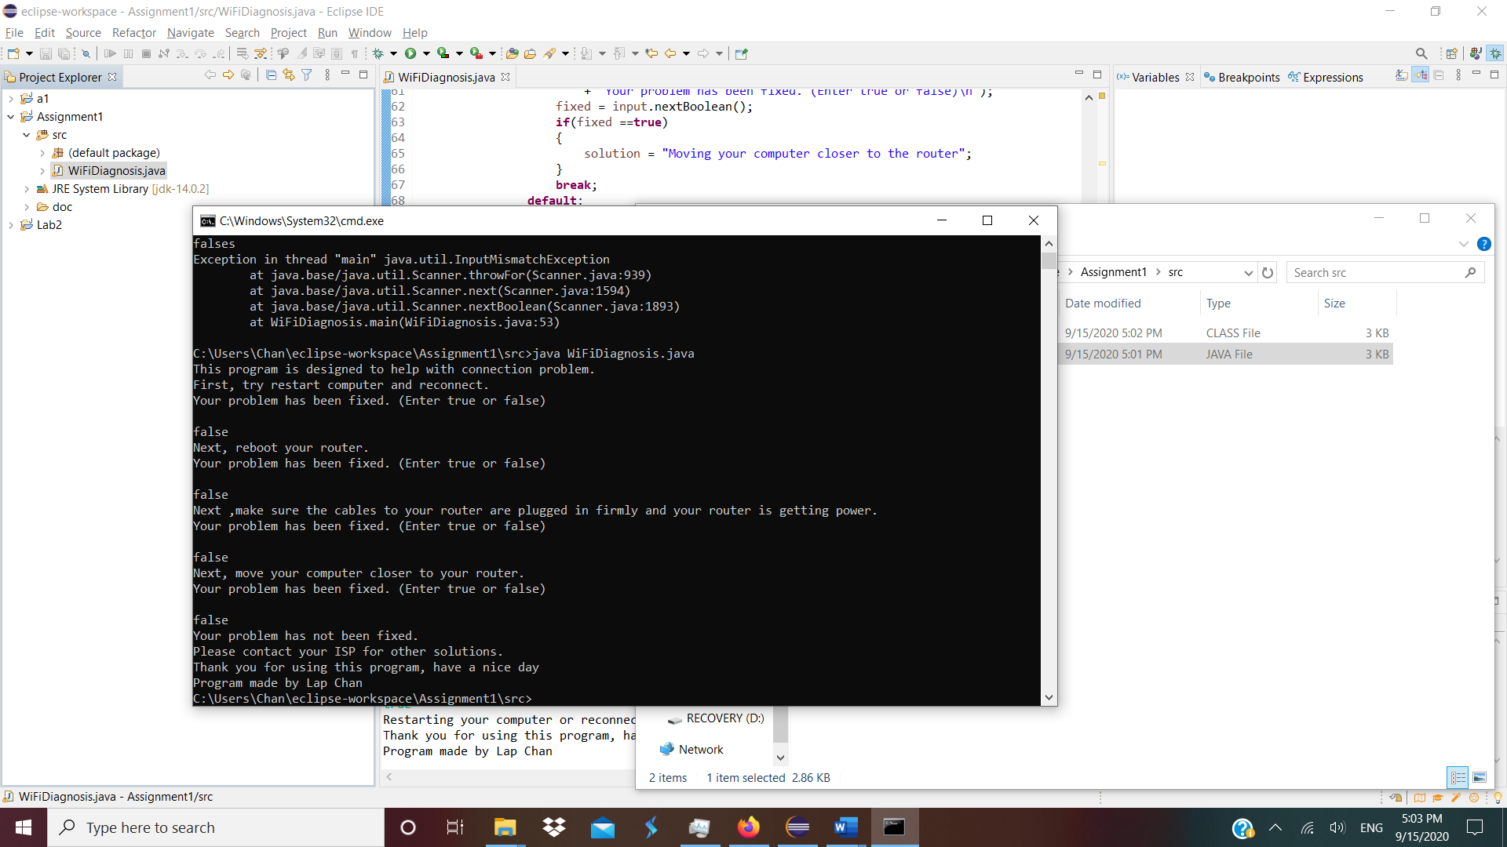

Java Code screenshot

1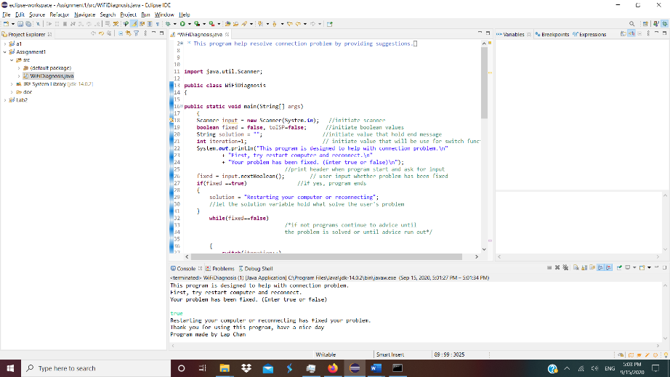

2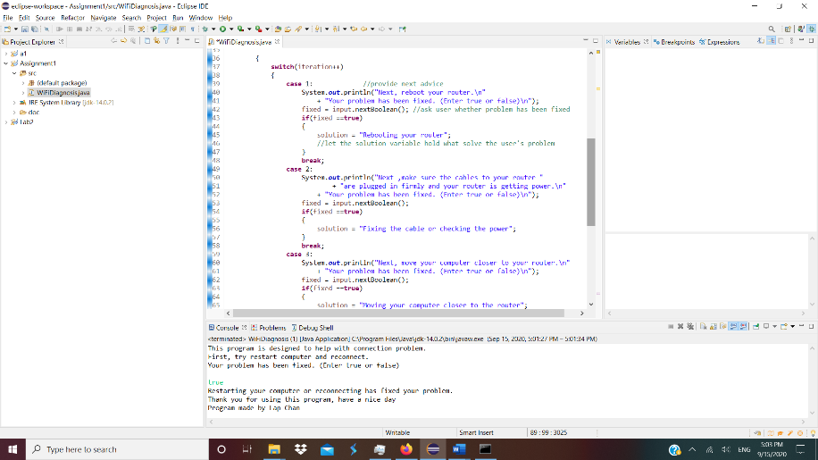

3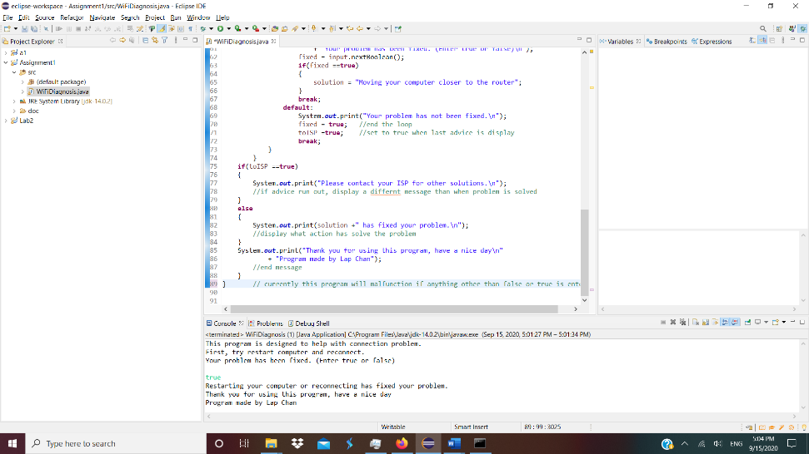

Reflection:

I learned how to make a basic Javadoc, which include a simple description, author name, and version. I also learn that pressing enter while in print string, new line of string will be automatically generated.

Many different methods were used to attempt to have the program work like the design. This include any nested if loop, while loop, for loop, an many combination of them. Almost all of my attempt with if loop ended with the program infinitely printing one line, the cause of which is due to a line of code that is suppose to update certain value not working.

As for the while loop or do while loop, the way I coded has way too many redundancy, which result in me abandoning this method. While for loop work fairly well at first, I realize I can make my code simpler using switch function, which is what I settle on at the end.

Currently, the program have no response to any input other than true or false.